VILLAGE NEWS

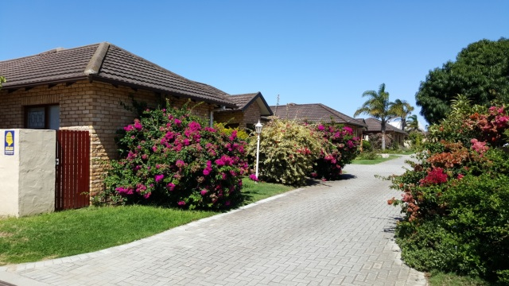
Walmer Park Village (Wpv), Church Road
Walmer Port Elizabeth 6070

Note: Information in this Newsletter is not necessarily the opinion of the Trustees of the Body Corporate.

August 2021

Village News: This newsletter was placed on hold after our Covid nightmares began. Now its restarted to keep owners and tenants informed of important Wpv matters; to be emailed to you as and when the need arises. The list of vital subjects is indeed lengthy but the looming water crises is now on top of our Wpv agenda.

Water: After 4 consecutive days of zero Municipal water in late July the seriousness of our situation is more apparent. There is no quick-fix (except for substantial rain in our catchment areas). Under investigation by Trustees/contractors are the following: borehole/pumps/reticulation/filtration etc, bulk tanks for delivered on site water, increasing the number of tanks at each Unit, Municipal tanker supply in streets and so on. To date The Grange and River Club successfully drilled for water in this precinct. Ground water quality is such that filtration may be essential for domestic use. If any owner wishes to email suggestions or opinions on this subject please do so – to Fspa.

No Water & Geysers: If mains water supply is off for some time the following advice from a plumber is interesting. With a correctly installed modern geyser it’s unnecessary to switch off electricity supply to the geyser element. A pressure geyser functions if the cold-water supply is under pressure. However, should hot water flow from the cold water tap immediately switch off power to the geyser. This probably indicates an anti-siphon connection is not installed. Or the new geyser was installed and inti-siphon loop is in place but the vacuum breakers weren’t replaced. Or for old geysers, a non-return can be installed upstream or a PRV. (Ref Bennett Plumbers, Gqeberha)

Security: Earlier this year a thief entered a garden at Wpv during the day but there was no break-in to the home. At Riverwoods two burglaries were reported where household items were stolen. Near Walmer Park Shopping Center a huge building is being erected. Construction, of course, increases the number of people in the precinct. As you will have noted contractors come and go at Wpv so the cautionary is to be aware and alert to the movement of people. Our back gate remains a vulnerable yet essential access point. If you/family/staff have keys it's vital that all are reminded to CHECK that the gate lock engages when closing. On a few occasions the gate was found to be unlocked. With only one main gate, the back gate is viewed as a necessary exit or entry point in the event of some serious crises.

Bidvest Development:

With the noise and dust one can hardly miss the new Bidvest development in progress on Wpv western boundary. During the conceptual phase Trustees were not contacted to object or comment. Local gossip is this will be a distribution point for Bidfoods, Cash & Carry and offices plus parking.

New Owners/Tenants: During the past 18 months a number of new residents arrived. Trustees take this opportunity to welcome them. Those who sold and left PE include a family now settled in Guernsey, others in Cape Town and Gauteng. The point here is that Wpv, correctly priced, remains a most desirable address for prospective buyers.

Cats: In keeping with a majority of townhouse developments cats are discouraged or not allowed. For good reason. In the past cats entered Wpv homes and urinated on curtains, carpets or in the gardens killed birds. Removing strong cat odours is extremely difficult. Cats in our neighbourhood are occasionally seen in Wpv village roads. They may be from other townhouses or from virtually anywhere. They are not to be encouraged or fed.

Main Gate (Intercom): The ‘preferred’ cell number selected at the time of the new installation is the ‘trigger’ number. On the intercom your visitor presses your Unit Number, your cell phone rings and by pressing number 1 on your phone the gate opens. Your ‘second’ cell number is accessed by your visitor by firstly pressing 2 – immediately followed by your Unit Number. The cell phone will ring on the ‘second’ number; the same opening process applies. However, Units 1 to 9 inclusive are the exceptions – for your ‘second’ number visitor presses 20 then the Unit number. This avoids confusion with other Unit numbers.

Main Gate (Security): After many years it is obvious that there are those drivers who refuse to wait for the gate to close. Owners/tenants and their families are often asked to remind everyone that our security is at stake. From 06 00 to 20 00 the gate opens as always but at night after 20 00 your remote must be used. This requires that you to go to the gate to open for your visitor. A measure of control in the dark hours.

Repainting Boundary Walls: MK Coatings is completing the initial phase of painting. Internal boundary walls will be painted during 2022.

Building Alterations/Additions: There are situations where improvements at your Unit require no approval. However, there are instances which definitely need formal Trustee and often Municipal approval. Check Conduct Rules and/or Fspa. It is at your peril if work is carried out, omitting the required consent. This is a normal situation in any group development to ensure that a good architectural standard is maintained. Note: Improvements may impact on your insurance cover. Check with Fspa. Contractor/DIY work is not permitted on Sundays and cut-off time for any work which may interfere with neighbours is 18 00 hours Monday to Saturday.

